Manipal University Jaipur

Department of Chemical Engineering

CE 1707- PROCESS PLANT DESIGN

IV YEAR, VII SEMESTER, 2019

MINI-PROJECT FINAL REPORT



INSTRUCTOR(S):

Dr. Anees Y. Khan

SUBMITTED BY : AKSHAY SRIVASTAVA

: SHUBHAM PARUTHI

: VINAMRATA VERMA

Contents

Executive Summary iii

1 Introduction 4

1.1 Ethyl Benzene Reaction System 4

1.2 Methods of Producing Ethyl Benzene 5

2 Process Simulation 12

2.1 HYSYS Simulation Fluid Property Package 12

2.2 Reaction Kinetics 12

2.3 HYSYS Process Flow Diagram 14

2.4 Section 1: Feed Preparation 15

2.5 Section 2: Alkylation Reaction and Effluent Cooling 18

2.6 Section 3: Benzene and Ethyl Benzene Separation 20

2.9 Energy Requirement Summary 24

3 Market Survey 25

3.1 UOP Process 25

4 Costs 25

4.1 Equipment Costs 25

4.2 Capital Costs 27

4.3 Direct Operating Costs 27

4.4 Profitability 28

Minimum Energy Requirement (From ASPEN HYSYS v9.0) 29

Conclusions 31

References 31

# Executive Summary

An ethyl benzene plant has been designed using a liquid phase alkylation of benzene with ethylene. The process is implemented at the Nova Chemical styrene plant in Sarnia, Ontario. Several EB synthesis processes were evaluated: the Mobil/Badger gas-phase process, the Alcar/AlCl3 liquid phase process, and the Lummus/UOP EBOneTM liquid phase process. The EBOneTM process was selected as a basis because it uses a safe and less expensive fixed bed catalyst, moderate operating conditions, and low benzene-to- ethylene feed ratio.

A benzene-ethylene feed is introduced into an alkylation reactor assembly forming EB and undesired di-ethyl benzene. A distillation separation system composed of two columns is used to separate benzene and EB from the main process stream. Benzene is recycled to the alkylation feed and transalkylation section. The transalkylation reactor is then used in conjunction with a recycled benzene feed to convert separated DEB to additional EB. This stream is recycled to the entrance of the separations system. The HYSYS 9 simulation software package was used to model the necessary unit operations and processes in the EB synthesis process. Based on the current simulation and a plant capacity of 18,000 kg/h (156,000 tonne/a) of EB, the plant has a positive net present value of US$ 7.2 million. The plant capital investment is estimated at US$ 23 million, with total operating costs at approximately US$ 160 million. Product revenue is estimated at US$ 175 million in EB sales, at a current selling price of US$ 1.12/kg. The vast majority of un-reacted benzene is recycled, and a negligible amount is purged to tankage.

# 1 Introduction

The reaction of benzene with ethylene produces ethyl benzene and by-product di-ethyl benzene. Ethyl benzene is an intermediate in the production of styrene. There are multiple technologies in current practice in the styrene industry. The fundamental differences are related to the reaction phase and vessel system. In the following sections, several methods of ethyl benzene production are explored to determine which technologies offer the best combination of profitability and inherent safety.

## 1.1 Ethyl Benzene Reaction System

The proposed plant design involves creating ethyl benzene from the raw components of benzene and ethylene. The chemical reaction to create ethyl benzene is:

C6H6 + C2H4 → C6H5C2H5 (1.1)

Eq.(1.1) for the reaction of benzene and ethylene to form EB is accompanied by five side reactions. Three of them are shown in Eq. (1.2), (1.3), and (1.4).

|  |  |
| --- | --- |
| C6H6 + 2C2H4 → C6H4(C2H5)2 | (1.2) |
| C6H5C2H5 + C2H4 → C6H4(C2H5)2 | (1.3) |
| C6H6 + C6H4 (C2H5)2 ⥨ 2C6H5C2H5 | (1.4) |

The reaction illustrated in Eq. (1.2) and (⥨1.3) produces an undesired product, DEB.

Proper use of LeChatelier’s Principle can force the equilibrium reaction described by Eq. (1.4) to yield as much desired product (EB) as possible. Eq. (1.5) and (1.6) show two further side reactions, but are negligible for simulation purposes.

|  |  |
| --- | --- |
| C6H5C2H5 + C2H4 → CH3C6H4C3H7 | (1.5) |
| C6H5C2H5 + C2H4 → (CH3)2C6H3C2H5 | (1.6) |

The kinetics for these two reactions were not found to be documented in literature. However it has been shown that the reaction extents for both reactions are negligible when simulating the process.1 As such, Eq. (1.1)-(1.4) shall be used for design in HYSYS. Several process designs can be implemented to favour the production of EB.

Several methods for creating ethyl benzene are discussed in the proceeding section.

## 1.2 Methods of Producing Ethyl Benzene

Most production methods of creating ethyl benzene have approximately 95 mol% conversion.1 The three methods discussed in this report include the creation of ethyl benzene in the gas-phase reaction (Mobil/Badger), in the liquid phase using an AlCl3 acid catalyst, and a liquid phase reaction in fixed bed reactors using a zeolite catalyst.

1.2.1 Gas-phase Production Using Zeolite Catalysts (Mobil/Badger)

The gas-phase reaction to create ethyl benzene using a zeolite catalyst is referred to as the Mobil/Badger process. The mechanism for creating EB differs from the AlCl3 and Alcar process (see Section 1.2.2), since the zeolite catalyst produces a carbonium ion which activates the ethylene to create an adsorbed electrophilic species which is quickly attacked by benzene. This in turn causes a faster reaction; however, more byproducts are produced as well which have to be recycled and converted back to useful product using a transalkylator.

Approximate operating conditions are 675-725 K and 200-400 psig. The operating conditions are significantly higher than those for the liquid phase process, resulting in higher risk and cost of operation. In addition, the benzene/ethylene ratio is approximately 8-16 by mole fraction for the gas-phase reaction. Such a large ratio is needed since the catalyst used is highly deactivated by the presence of ethylene as more carbonaceous species are created.

Catalyst life using a gas-phase reaction is a major downfall of the gas-phase process. The catalyst requires regeneration every two to four weeks. To maintain steady state operation, it is typical to run two reactors in parallel. Because of this, the costs associated with this process are high as shutdown costs, catalyst costs, and deactivated catalyst disposal are high. In addition, because the B/E ratio is high, the costs of operation are higher in order to retrieve and recycle the excess benzene.

The gas-phase reaction does have some positive aspects. The zeolite catalyst is safer environmentally and disposal costs are not as high. Also, the catalyst is non-corrosive and therefore special materials, which are required for the AlCl3 and Alcar process, are not required. However, the catalyst life problem is a major issue with this process. The AlCl3, Alcar, and liquid process using zeolite catalysts resolve this issue. Figure 1.1 illustrates the operation of a Mobil/Badger process.2

1.2.2 Liquid Phase Production with AlCl3: Friedel-Crafts/Alcar Process

One method of creating EB is through a Friedel-Crafts reaction of ethylene in the presence of an aluminum chloride acid catalyst (AlCl3). This reaction occurs in the liquid phase and is illustrated in Figure 1-1.

R

AlCl

3

(cat)

R

X

-

HX

Figure 1-1: Friedel-Crafts alkylation of Benzene to form EB.

Where

R = Ethylene group

X = Chlorine atom

With this process, the AlCl3 is injected as fine particles into the alkylator reactor where the ethyl benzene is formed. The AlCl3 is quite often promoted with HCl or ethylene chloride to reduce the amount of AlCl3 required for the reaction. Once through the reactor, the AlCl3 is filtered out of the product by water washing and then sent for disposal or regeneration. To recover the unwanted di-ethyl benzene and other unwanted products, a transalkylator is commonly used. Here, the unwanted products are reconverted to EB, hence increasing feed conversion.2

The liquid phase process has several advantages over the gas-phase process because temperatures and pressures are reduced which lead to saving in operating costs. In addition, the operation is safer since operating conditions are not as severe. Typical running conditions for temperature and pressure are between 420-470 K and 70-150 psig for the alkylation and transalkylation processes. In addition, the benzene/ethylene (B/E) ratio is lower at approximately 1.5-2.5 by mole ratio.

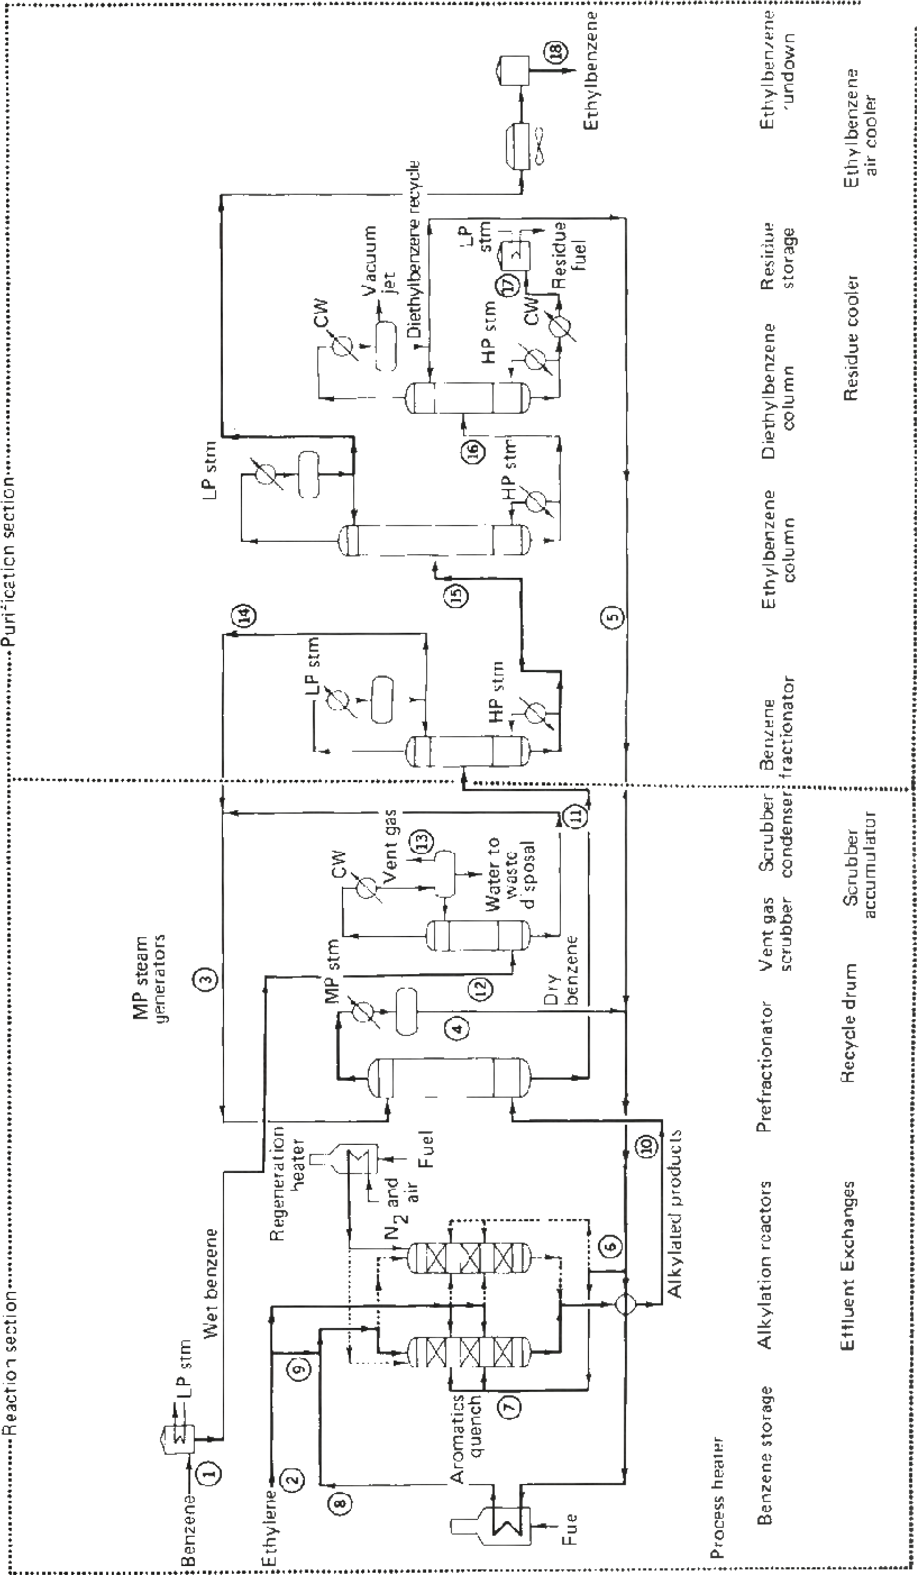

Figure 1: Mobil/Badger Process

Having a lower B/E ratio reduces the operation costs associated with removing the unreacted benzene and provides a more economical plant operation.2 Another positive aspect of the liquid phase reaction is that the catalyst is not subjected to high deactivation rates. However, this type of catalyst does have some downfalls.

The catalyst used in the AlCl3 process is an acid, which tends to corrode the operating equipment unless the internals of the equipment are lined with special materials (such as brick or glass). The use of such materials increase construction costs and may be expensive to maintain as some are quite fragile. In addition, the catalyst is injected and removed from the process on a continuous basis, leading to higher operation costs in water and filtration when the catalyst is separated from the process stream. Finally, the AlCl3 catalyst is hazardous to the environment and there are relatively high costs involved in assuring that it is stored and disposed of properly.

Further process designs, such as the Alcar Process from Universal Oil Products (UOP) resolved some of the downfalls of the AlCl3 process. It used a fixed bed of BF3 catalyst which had reduced corrosion concerns and eliminated the need for continuous catalyst removal. However, the Alcar process did require much higher operating pressures of approximately 500 psig and therefore increasing operating costs. Also, the problem of the AlCl3 catalyst disposal was also present when using the BF3 catalyst. The AlCl3 and Alcar processes are shown in Figures 1-3 and 1-4, respectively.

Research continues for the use of a zeolite catalyst in a fixed bed for a liquid phase reaction of ethylene and benzene to create ethyl benzene.2

1.2.3 Liquid Phase Reaction Using Zeolite Catalyst in a Fixed Bed

Similiar to the Mobil/Badger process, the liquid phase reaction uses a zeolite catalyst which does not require special material for reactor internals, piping, or in other parts of the process. In addition, the zeolite catalyst is not as harmful to the environment which saves in disposal costs.

This process, like the preceding AlCl3 and Alcar process, requires an alkylator and a transalkylator. In addition, the operating temperature and pressures are similar to that of the AlCl3 process. The B/E alkylator feed ratios range from 1.5-2.0 on a molar basis. Since temperatures and pressures are not extreme and B/E ratios are relatively low, there are large savings available in operational costs when compared to the Mobil/Badger process. Further, since the catalyst is contained in fixed beds there are reduced operational costs when compared to the AlCl3 and Alcar process because the catalyst does not have to be continuously removed from the process using a filter and washing.

Figure 1-3: Production of EB using AlCl3

3

process.

2

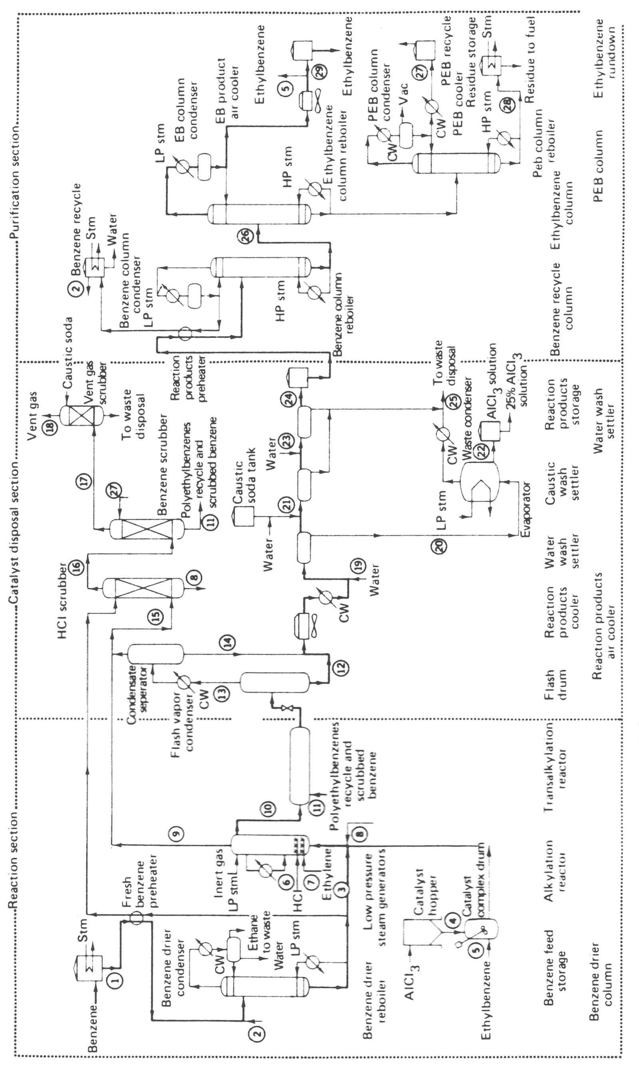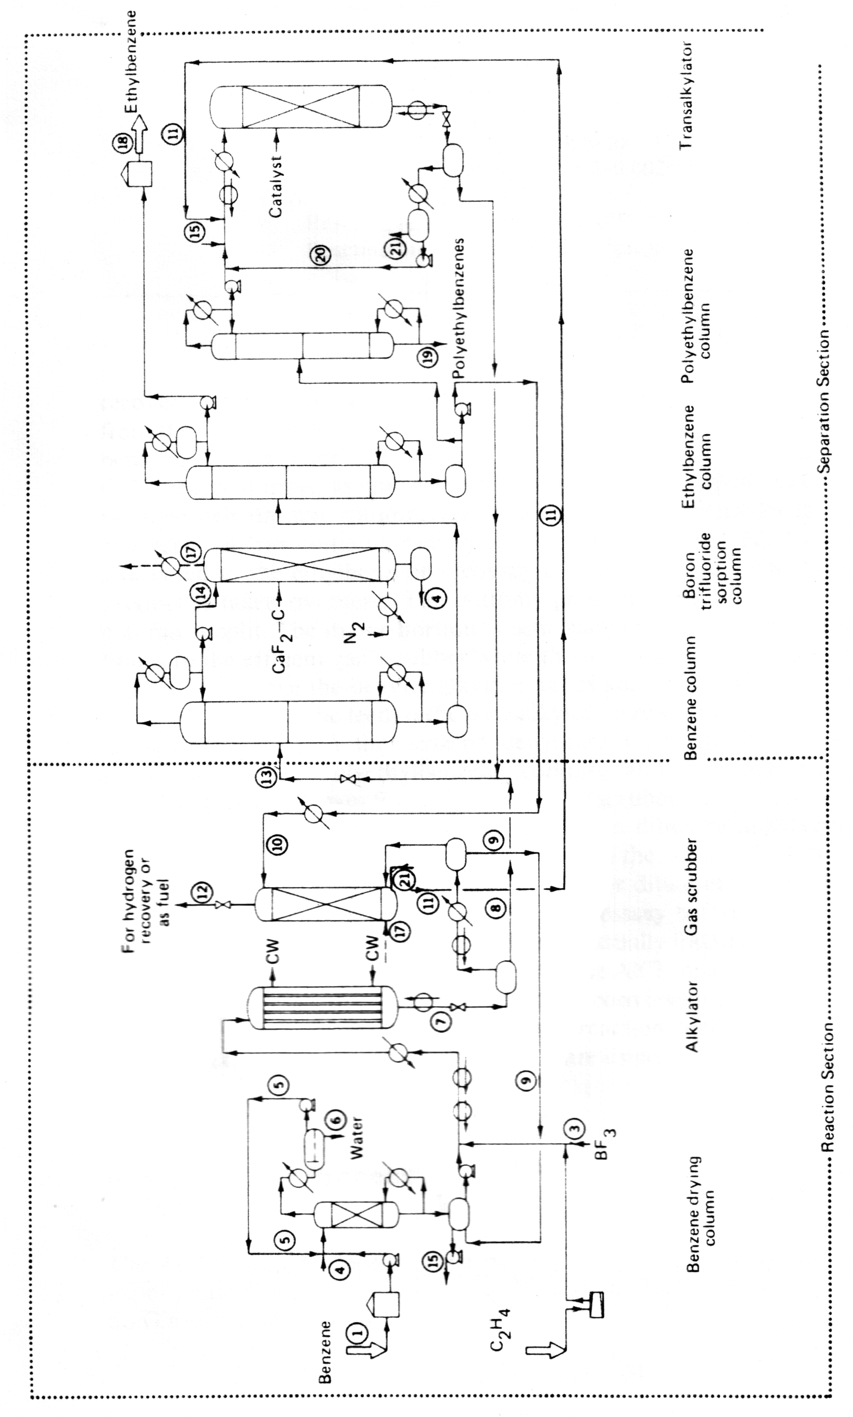

Figure 1-4: Production of EB using the Alcar process

The most positive aspect of the EBOne process is that catalyst life is claimed to be at least five years for the alkylator and the transalkylator when using the EBZ-500™ and EBZ-100™ as the fixed bed catalyst, respectively. Also, these catalysts may be regenerated for at least three cycles. Therefore, they constitute a more economical alternative to conventional catalyst. Further savings are realized since shutdowns are less frequent to change out the catalyst in the fixed beds of the reactors. A diagram of the EBOne process is shown below in Figure 1-5.

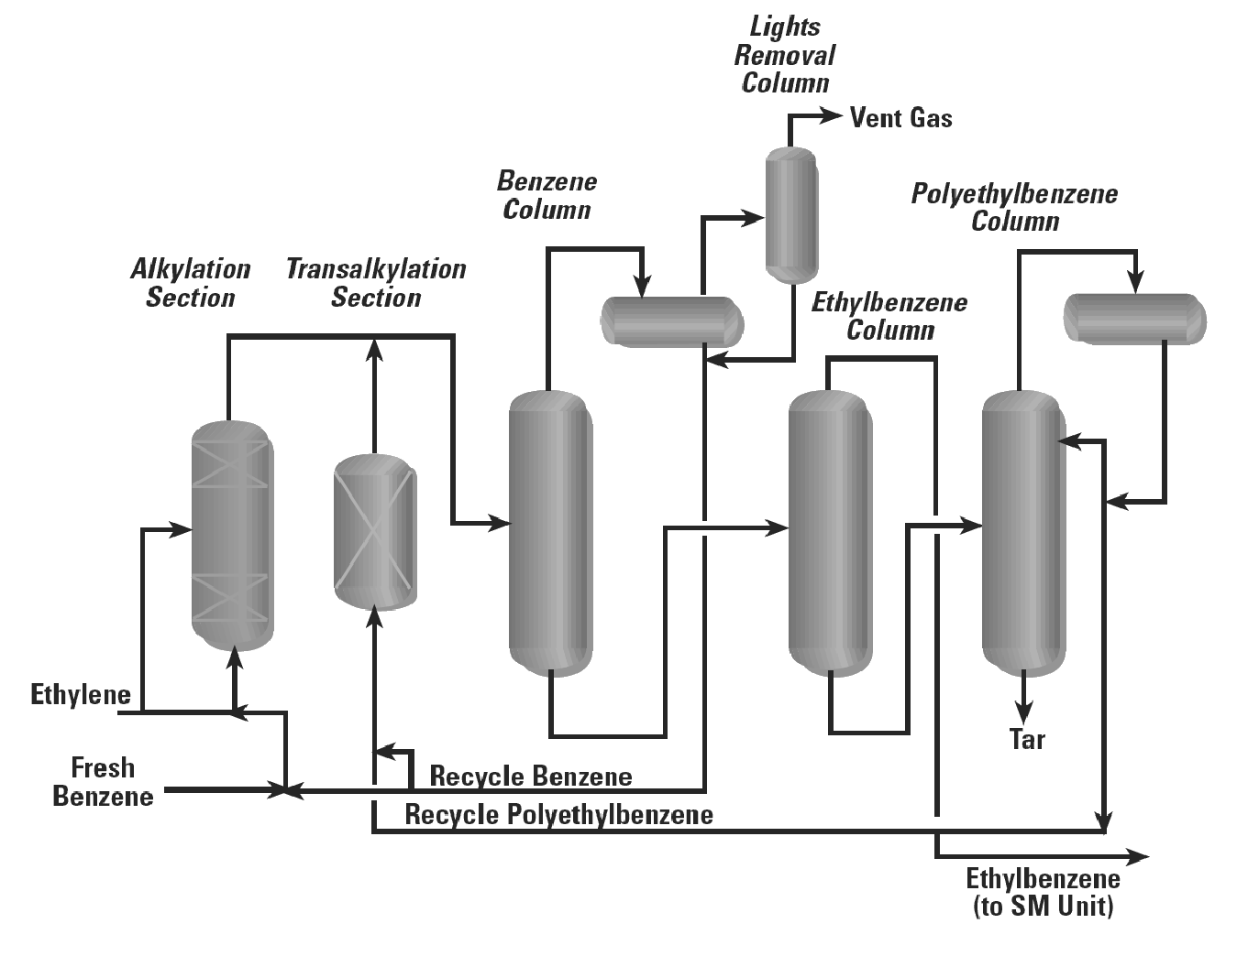

Figure 1-5: EBOne process.3

As Figure 1-5 shows, the main reaction takes place in the “Alkylation Section” in the presence of the EBZ-500™ catalyst in fixed beds. The ethylene and benzene react to form the product ethyl benzene and other unwanted products. The top product of this reactor flows to the “Benzene Column” where the excess benzene is removed from the product stream and then sent back as recycle with “Fresh Benzene”. The remaining gas is then sent to a “Lights Removal Column” where any un-reacted ethylene is sent to a flaring system. Any un-separated benzene is also combined with the recycled benzene stream.

The bottoms of the “Benzene Column” are sent to the midsection of the “Ethyl Benzene Column”. The ethyl benzene product is separated from the other unwanted products as distillate and then sent to storage. The bottoms of the “Ethyl Benzene Column” are sent to the mid section of the “Poly-ethyl Benzene Column”. The distillate of this column is condensed and combined with some recycle benzene and then sent to the “Transalkylation Section”. In the “Transalkylation Section” the side reaction (DEB and TEB) products are reacted in the presence of the EBZ-100™ catalyst in fixed beds to form more ethyl benzene. The top product of “Transalkylation Section” is then combined with the top product of the “Alkylation Section”, where it repeats the process loop. The bottom product of the “Poly-ethyl Benzene Column” is mostly a viscous tar material which is disposed of as a waste material.

1.2.4 Process Selection

The EBOne process offers the best economical benefits, operating conditions, safety, and environmental considerations. The EBOne process has been successfully used in 15 fully operational plants with capacities ranging from 65,000 tonne/yr to 200,000 tonne/yr. Five more plants are in the construction phase licensing the EBOne process. The first plant has being operating at full capacity for 12 years.3 Low operating conditions, liquid phase reactions, and the environmentally friendly zeolite catalyst were the primary determinants in selecting this process for a design basis.

# 2 Process Simulation

## 2.1 HYSYS Simulation Fluid Property Package

The Peng-Robinson property fluid package was used for this simulation. It utilizes the Peng-Robinson (PR) equation of state model which can be seen in the HYSYS help manual. It was chosen because the PR model gives good results for non-polar systems, and has a wide range of materials that can be used for accurate results. All the components used in the production of EB are either non-polar or contain very weak dipole moments. It was also noted that HYSYS contained all the necessary interaction parameters for the PR EOS model, which sharply improves accuracy.

## 2.2 Reaction Kinetics

Kinetics for the “Alkylation Section” are taken from Qi and Zhang (2004)1. The kinetics takes into account the use of zeolite catalyst. The reaction of benzene with ethylene to produce the product ethyl benzene is as follows:

C6H6 +C2H4 →C6H5C2H5 2 $r_{1}=8.4×{10}^{-5}\exp\left({-45.8}/{RT}\right)C_{E}^{1}C_{B}^{0.32}$ (2.7)

The reaction of benzene with two moles of ethylene to produce di-ethyl benzene is as follows:

C6H6 +2C2H4 →C6H4(C2H5)2 $r_{2}=6.03×{10}^{-4}\exp\left({-61.6}/{RT}\right)C_{E}^{1.3}C_{B}^{0.33}$ (2.8)

The reaction of ethyl benzene with ethylene to produce di-ethyl benzene is as follows:

C6 H5C2H5 +C2H4 →C6H4(C2H5)2 $r_{3}=8.5×{10}^{-5}\exp\left({-86.4}/{RT}\right)C_{E}^{1.77}C_{B}^{0.35}$ (2.9)

The three kinetic equations above have the units of kgmole/m3s. The activation energies given in Qi and Zhang (2004) did not contain information on units. A second source indicated that the units were kcal/mol.7 The results of a conversion of the activation values into kJ/kgmol are shown above in Eq. (2.7)-(2.9). The equilibrium reaction of benzene with di-ethyl benzene to form two moles of ethyl benzene is as follows:

C6H6 + C6H4(C2H5)2 ⥨ 2 C6H5C2H5 (2.10)

The reactions for the “Transalkylator Section” were modeled using the equilibrium expression in Eq. (2.10). These were derived using thermodynamic assumptions described in literature.8 The equilibrium constant can be related to temperature using the following expression:

$\ln\left(K/{K^{'}}\right)=-\frac{△H°}{R}\left(\frac{1}{T}-\frac{1}{T^{'}}\right)$ (2.11)

Where

K = Equilibrium constant at temperature T

K′ = Reference Equilibrium constant at temperature T’

H° = Standard enthalpy change of reaction

T = Arbitrary temperature

T′= Reference temperature at value of Equilibrium constant K

These values had a K value of 0.883 and a T value of 571 K.1 The standard reaction enthalpy was determined using HYSYS as -2.4x103 J/mol. Manipulation of Eq. (2.11) and substituting the appropriate values in for variables yields Eq. (2.10). In the following section, a detailed description of the simulation in HYSYS will be presented discussing each major unit operation with its function, parameters such as height, diameter, required work/duty, etc.

## 2.3 HYSYS Process Flow Diagram

Figure 2-1 shows the HYSYS process flow diagram in its entirety. There are 14 main process operations contained in five sections of the plant. Table 2-1 summarizes the PFD labels of these operations with descriptions of the equipment and the section of the plant in which they are contained. Table 2-2 shows a summary of each of the five sections of the plant.

Table 2-1: Operation-section key

|  |  |  |
| --- | --- | --- |
| PFD Label | Operation Description | Plant Section |
| P-1 | Fresh benzene feed pump to Alkylator | Section 1 |
| E-1 | Alkylation Feed Cooling System | Section 1 |
| P-2 | C-1 Recycle Pump | Section 1 |
| R-1-1A/R-1-2A | Train One Alkylation Section | Section 2 |
| R-2-1A/R-2-2A | Train Two Alkylation Section | Section 2 |
| R-1-1B/R-1-2B | Train One Equilibrium Reactor | Section 2 |
| R-2-1B/R-2-2B | Train Two Equilibrium Reactor | Section 2 |
| VLV-100 | Alkylation Effluent Pressure Reducer | Section 2 |
| E-2 | R-1 Assembly Cooling system | Section 3 |
| C-1 | Benzene Separation Column | Section 3 |
| C-2 | EB Separation Column | Section 3 |
| C-3 | Flash Drum | Section 3 |
| E-3 | C-2 Cooling system | Section 4 |
| R-3-1A | Transalkylation Alkylator | Section 4 |
| R-3-1B | Transalkylation Equilibrium Reactor | Section 4 |

Table 2-2: Plant section description.

|  |  |
| --- | --- |
| Section  Number | Brief Description |
| Section 1 | Feed preparation section of the plant. Its purpose is to prepare the feed components for the reactions in Section 2. |
| Section 2 | Alkylation section of the plant which is divided into two trains of reactors. The purpose of this section is to form ethyl benzene from ethylene and benzene raw components. It contains four real reactors, a reducing valve and a cooling system. |
| Section 3 | Benzene and ethyl benzene separation section of the plant. It contains two distillation columns and a flash drum. |
| Section 4 | Transalkylation section of the plant. Converts some of the diethyl benzene to ethyl benzene using C-1 benzene recycle |

A detailed description of each section is discussed in the following sections. Operating conditions, performance, design specifications are discussed in further detail.

## 2.4 Section 1: Feed Preparation

The purpose of this section of the ethyl benzene plant is to prepare the feed components for processing in Section 2 of the plant where the alkylation reaction occurs. This section handles a large recycle benzene stream which is combined with the raw feed components.

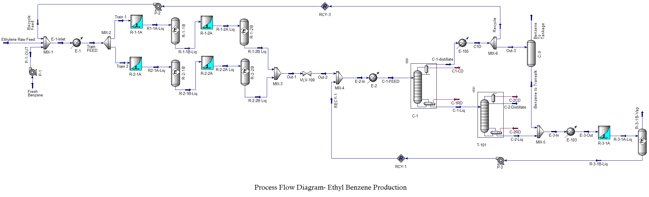

Section 1 of the EB plant includes the fresh feed streams of benzene and ethylene, the benzene feed pump (P-1), the benzene recycle pump (P-2), and the R-1/R-2 assembly feed cooler (E-1). The raw ethylene arrives on site from a pipeline which operates at approximately 4 MPa and is reduced to 1.8 MPa before entering the main plant. The feed and recycle are mixed then cooled using a cooling water system (E-1).

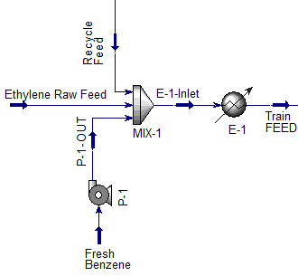

Figure 2-2: Section 1 feed preparation.

Table 2-3 summarizes the composition, operating conditions, and flow rates for the important streams.

Table 2-3: Section 1 conditions.

|  |  |  |  |  |  |
| --- | --- | --- | --- | --- | --- |
|  | Fresh Benzene | Ethylene Raw Feed | E-1-Inlet | TrainFeed | Recycle Feed |
| Temperature [°C] | 25 | 268 | 90 | 40 | 83 |
| Pressure [kPa] | 101 | 1800 | 1800 | 1780 | 1800 |
| Mass Flow Rate [kg/h] | 14,500 | 4769 | 78,530 | 78.530 | 59,260 |
| Benzene Mole Frac. | 0.99 | 0.0 | 0.83 | 0.83 | 0.98 |
| Ethylene Mole Frac. | 0.00 | 1.0 | 0.17 | 0.17 | 0.02 |

To pump the fresh benzene to the reactor conditions of 1.8 MPa, the pump requires 10.5 kW of power when running at 75% efficiency. In order to prevent catalyst deactivation, the feed ratios of the benzene/ethylene (B/E ratio) are adjusted using a spreadsheet (Feed Ratios and Reactor Calculations) to a value of 5.5 on a molar basis. This ratio may be reduced further to approximately 1.4 by the addition of more ethylene. However, the HYSYS simulation became unstable for any attempts to decrease the ratio. If this ratio is decreased any further than 1.4, the deactivation of the zeolite catalysts in the R-1 assembly becomes a major issue requiring the shutdown of the R-1 reactor for catalyst re-activation or worse, replacement.1 It should be noted that increasing this ratio in HYSYS drastically improved the benzene conversion, however HYSYS does not take catalyst deactivation into account, and as such, the simulation is bound to this constraint.9 The desired B/E ratio from the reactor inlet steam (Train Feed) is controlled in the HYSYS simulation through a spreadsheet (“Feed Ratios and Reactor Calculations”).

The E-1 cooler is simulated with a simple cooling utility.

## 2.5 Section 2: Alkylation Reaction and Effluent Cooling

Section 2 of the ethyl benzene plant consists of a benzene/ethylene alkylation reactor assembly which forms the product compound of ethyl benzene and other by-products such as diethyl benzene. The assembly is divided into two trains, Train 1 and Train 2. Each train consists of two CSTR reactors and two equilibrium reactor models to simulate the non-reversible and equilibrium reactions, respectively, represented in Eq. (2.7)-(2.10). The overall purpose of this section of the plant is to facilitate a reaction to produce ethyl benzene at the highest yield and level of safety as possible. A schematic of this section of the plant is illustrated in Figure 2-3.

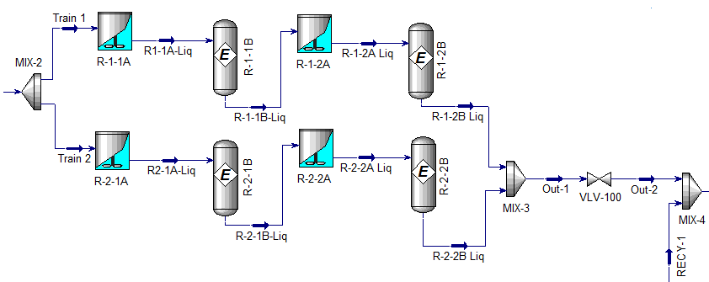

Figure 2-3: Section 2 alkylation reactor assembly.

The two trains are identical to each other in terms of mass flow rate, pressure, temperature, and composition. Table 2-4 summarizes the process details for each reactor while the conditions for the Recycle 2 and E2 Inlet stream can be seen in Table 2-5.

Table 2-4: Section 2 reactor conditions.

|  |  |  |  |  |
| --- | --- | --- | --- | --- |
|  | R-1-1-A/ R-2-1 | R-1-1B-Liq/ R-2-1B | R-1-2A/ R-2-2A | R-1-2B  R-2-2B  138 |
| Temperature (°C) | 125 | 125 | 138 |
| Pressure (kPa) | 1700 | 1700 | 1700 | 1700 |
| Mass Flow Rate (kg/h) | 39,210 | 39,210 | 39,210 | 39,210 |
| Benzene Mole Frac. | 0.870 | 0.822 | 0.837 | 0.821 |
| Ethylene Mole Frac. | 0.073 | 0.073 | 0.021 | 0.021 |
| EB Mole Frac | 0.00 | 0.096 | 0.107 | 0.14 |
| DEB Mole Frac. | 0.056 | 0.0081 | 0.034 | 0.017 |

Table 2-5: Recycle 2 and E2 Inlet stream data.

|  |  |  |
| --- | --- | --- |
|  | Recycle 2 | E2 In |
| Temperature (°C) | 20 | 115 |
| Pressure (kPa) | 500 | 500 |
| Mass Flow Rate (kg/h) | 22,540 | 100,000 |
| Benzene Mole Frac. | 0.846 | 0.826 |
| Ethylene Mole Frac. | 0.007 | 0.018 |
| EB Mole Frac | 0.135 | 0.016 |
| DEB Mole Frac. | 0.012 | 0.016 |

The volume of each CSTR model is approximately 35m3 , which are ordered in series for both trains as illustrated in Figure 2-3. Realistically, a reactor reaches its size limit around 250 m3. The reactor volume had a negligible effect on the benzene conversion. HYSYS encountered some difficulties in performing accurate case studies to optimize the reactor volumes. However, 35m3 was the smallest volume to which HYSYS would converge without giving inappropriate results.

At steady state, the R-1 assembly runs at 125°C and 1700 kPa in which there is a 13°C exotherm in the second R-1 of each train. These process conditions are based on U.S. Patent 6,504,071 and most conditions fall within the proposed ranges.10 To improve heat efficiency of the plant, the reactors were allowed to provide more exotherm instead of using large amounts of energy to cool the reactant contents. The reactor outlets are cooled just enough to maintain them in the liquid phase. As a result, the reactant outlets do not require heating to become a saturated liquid before entering C-1. Since cooling water is cheaper then steam this more economical.

In order to obtain a respectable life of the EBZ-500TM catalyst, the B/E ratio must be maintained as high as possible in order to keep ethylene as a limiting reagent, and therefore limiting its interaction with the catalyst and causing deactivation. As previously stated, the deactivation of the catalyst increases operational costs in the forms of increased shutdowns and catalyst replacement and regeneration. However, this ratio must also be kept as low as possible to prevent high separation cost of benzene in C-1.

## 2.6 Section 3: Benzene and Ethyl Benzene Separation

Section 3 of the ethyl benzene plant consists of two distillation columns (C-1 and C-2) and a flash drum (C-3). This section of the plant is used to separate benzene and ethyl benzene from the main process stream. A schematic of this section of the plan is shown in Figure 2-4.

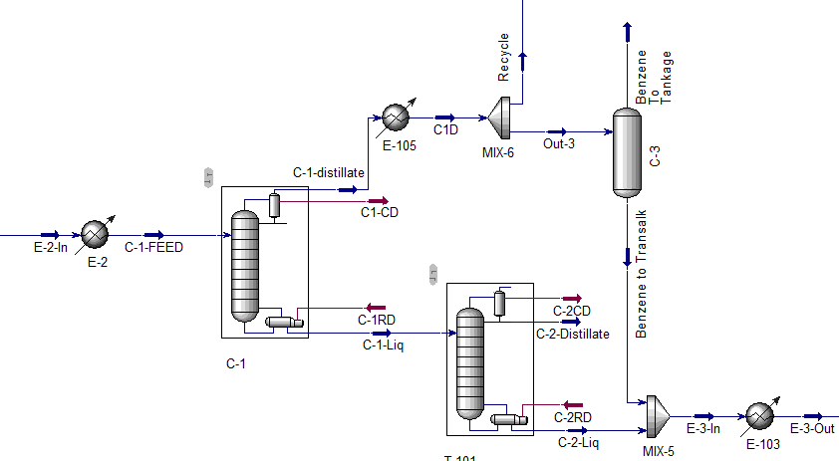

Figure 2-4: Section 3 benzene and ethyl-benzene separation.

The benzene separation occurs in C-1 in which the distillate stream is 99.7% benzene (m.f.). A portion of the distillate proceeds to C-3 for flaring and to provide benzene to the transalkylation section. This is accomplished by invoking a 40 kPa pressure drop allowing some of the process stream to flash off. The remainder is recycled back to the feed section of the plant for further reaction in the R-1 assembly. The bottoms of the column proceed to C-2 for further separation. Process details of C-1 inlets and outlets are detailed in Table 2-6 and the process details of C-3 can be seen in Table 2-7.

Table 2-6: Section 3 C-1 process data.

|  |  |  |  |
| --- | --- | --- | --- |
|  | C-1-Feed | C-1-Distillate | C-1-Liquid 194 |
| Temperature [°C] | 107 | 83 |
| Pressure [kPa] | 470 | 400 | 400 |
| Mass Flow Rate [kg/h] | 101,000 | 79,470 | 21,470 |
| Benzene Mole Frac. | 0.083 | 0.976 | 0.051 |
| Ethylene Mole Frac. | 0.018 | 0.022 | 0.001 |
| EB Mole Frac. | 0.139 | 0.002 | 0.848 |
| DEB Mole Frac. | 0.016 | 0.0 | 0.100 |

Table 2-7: Section 3 C-3 process data.

|  |  |  |  |
| --- | --- | --- | --- |
|  | Out-4 | Benzene to Tankage | Benzene to  Transalk 82 |
| Temperature [°C] | 83 | 82 |
| Pressure [kPa] | 400 | 360 | 360 |
| Mass Flow Rate [kg/h] | 19,820 | 47 | 19,770 |
| Benzene Mole Frac. | 0.977 | 0.311 | 0.991 |
| Ethylene Mole Frac. | 0.022 | 0.689 | 0.007 |
| EB Mole Frac. | 0.002 | 0.00 | 0.002 |
| DEB Mole Frac. | 0.00 | 0.00 | 0.00 |

C-1 is approximately 16.3 m high, has a diameter of approximately 3.4 m, and contains 27 actual trays (assuming a tray efficiency of 60%). The feed stage is on tray number 19, where the column is numbered from top to bottom. C-1 removes 99.5% of the benzene from the process stream. The reflux ratio is 15.8 and the column has a pressure drop of 70 kPa.

The bottoms of C-1 are sent to C-2 where ethyl benzene is separated from diethyl benzene. C-2 is approximately 20.3 m high, has a diameter of 2.3 m, and contains 33 trays assuming 60% tray efficiency. C-2 removes 99.9% of the ethyl benzene from the process stream. Table 2-8 illustrates the process details of C-2. The distillate stream of C-2 is the product stream of ethyl benzene while the bottoms of the column are mainly diethyl benzene which is transalkylated to produce more diethyl benzene product.

Table 2-8: Section 3 C-2 process data.

|  |  |  |
| --- | --- | --- |
|  | C-2-Distillate | C-2-Liq |
| Temperature [°C] | 185 | 240 |
| Pressure [kPa] | 360 | 360 |
| Mass Flow Rate [kg/h] | 18,770 | 2700 |
| Benzene Mole Frac. | 0.042 | 0.0 |
| Ethylene Mole Frac. | 0.0 | 0.0 |
| EB Mole Frac. | 0.978 | 0.007 |
| DEB Mole Frac. | 0.0 | 0.993 |

Table 2-8 shows a summary of the design specifications of C-1 and C-2.

Table 2-8: Section 3 C1 and C2 design summary.

|  |  |  |
| --- | --- | --- |
|  | C-1 | C-2 |
| Height (m) | 16.3 | 20.3 |
| Width (m) | 3.4 | 2.3 |
| Number of Actual Trays (60% Efficiency) | 27 | 33 |
| Reflux Ratio | 15.8 | 2.1 |
| Re-boiler Duty (kW) | 16 | 5 |
| Condenser Duty (kW) | 16 | 5 |
| Feed Stage | 11 | 19 |

2.7 Section 4: Transalkylation

Section 4 of the EB plant design is the transalkylation reaction section. A diagram of this section is shown in Figure 2-5.

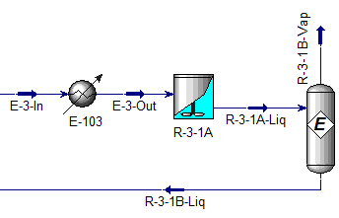

Figure 2-5: Section 4 transalkylation.

Approximately 23,000 kg/h enters the transalkylator. A breakdown of the stream components are shown in Table 2-6.

Table 2-6: Section 4 conditions.

|  |  |  |
| --- | --- | --- |
| Component | E-3-Out (mol %) | R-3-1B-Liq (mol %) |
| Benzene | 90.7 | 80.4 |
| Ethylene | 1.7 | 0.3 |
| EB | 0.2 | 17.4 |
| DEB | 7.2 | 1.9 |
| Toluene | <0.0001 | <0.0001 |

The Transalkylator (R-3-1A & R-3-1B) makes use of the equilibrium and CSTR models. Equilibrium kinetics were described in Eq. (2.11). Approximately an 83% conversion of EB to DEB was obtained. Conditions for the transalkylation section were not described in the supporting documentation for EB production. However, a paper documenting the transalkylation reaction of EB to form benzene and DEB operates their transalkylator at high temperatures (400-600 K).11 Since the reverse is required for this plant design, it is logical that lower temperatures are required for the reaction to produce EB. This is supported by inspection of Eq. (2.10). The transalkylation process is independent of pressure, and as such there is no reason to lower the pressure when it will need to be increased again for the recycle loop.12

The reactor has been sized at 30 m3. The simulation did not converge at lower volumes, and the conversion achieved at higher volumes was negligible. The bottoms of C-2 is mixed with the benzene recycle and cooled to 25°C and maintained at 360 kPa. A larger proportion of DEB is desired to increase the amount of EB formed, however this is related to the high benzene-ethylene ratio entering the R-1/R-2 assembly. There is too much unreacted benzene circulating the recycle streams, and not enough ethylene is present to increase the amount of EB and DEB formed.

## 2.9 Energy Requirement Summary

The energy requirements for the plant are summarized in Table 2-7. It is readily apparent that the largest utility costs are the condenser and re-boiler of the columns C-1 and C-2. Steam is used for the re-boiler requirements as the temperatures are not unrealistically large. Relatively low pressures are used in the plant resulting in low pump costs.

Table 2-7: Energy requirements summary.

|  |  |  |
| --- | --- | --- |
| Energy Stream | Unit | Power Req. [kW] |
| P-1-D | P-1 | 10 |
| P-2-D | P-2 | 40 |
| E-1 | E-1 | -2,150 |
| R-1-1A-D | R-1-1A | -110 |
| R-1-1B-D | R-1-1B | -34 |
| R-1-2A-D | R-1-2A | 490 |
| R-1-2B-D | R-1-2B | -10.5 |
| R-2-1A-D | R-2-1A | -110 |
| R-2-1B-D | R-2-1B | -34 |
| R-2-2A-D | R2-2A | 490 |
| R-2-2B-D | R-2-2B | -10.5 |
| E-2 | E-2 | -415 |
| C-1-CD | C-1 | 16,000 |
| C-1-RD | C-1 | 16,000 |
| C-2-CD | C-2 | 5,000 |
| C-2-RB | C-2 | 5,000 |
| E-3 | E-3 | 853 |
| R-3-1A-D | R-3-1A | -128 |
| R-3-1B-D | R-3-1B | -25 |
| P-3-D | P-3 | 1.5 |

# 3 Market Survey

Over 99.9% of the ethyl benzene produced in the world is used in the manufacture of styrene. Therefore, the demand for ethyl benzene is determined primarily by styrene production.16 EB is also used in the manufacturing of industrial solvents and, on occasion, in the production of diethyl benzene, acetophenone and ethyl anthrax-quinone.

## 3.1 UOP Process

In 1996, UOP and Lummus successfully commercialized a new zeolitic EBZ500 catalyst for the alkylation of benzene with ethylene to produce EB.19 The first commercial plant to use the liquid-phase process began production in 1990 by the Nippon Styrene Monomer Corporation (Japan). The plant used the UOC-4120 zeolite catalyst manufactured by UOP for both the alkylation and transalkylation reactors. Two subsequent plants were constructed in Japan in 1994, this time, using the newly developed EBZ-100 transalkylation catalyst. By 1997, full-scale plants were using EBZ-500 (the catalyst proposed for the current project) in South-East Asia, Japan, and Germany.

# 4 Costs

The current NPV of the plant is US$ 7 million. A new process technology is considered a medium level of risk.14 The rate of return (ROR) was determined to be 27%.

## 4.1 Equipment Costs

Equipment costs have been calculated for the current plant design based on available data from Peters and Timmerhaus.14 Estimated purchasing and installation costs are shown in Table 4-1. For economical reasons, carbon steel was selected for equipment construction. Carbon steel has suitable corrosion resistance for the chemicals used in the production of EB.14

Total purchasing costs in 2004 amount to US$ 3.6 million and total installation costs are US$ 2.3 million. The two distillation columns (C-1 and C-2) account for the largest portion (60%) of the equipment costs.

Table 4-1: Equipment costs (all equipment is carbon steel). EB = 156,000 tonne/yr

|  |  |  |  |
| --- | --- | --- | --- |
| Equipment | Description | Purchase  Cost,  US $ | Install  Cost,  US $ |
| CSTR (R-1) | 35 m3; CS jacketed; 300 psia | 121,800 | 54,800 |
| CSTR Motor (R-1) | 35 m3 | 2,600 | 1,200 |
| CSTR (R-1) | 35 m3; CS jacketed; 300 psia | 121,800 | 54,800 |
| CSTR Motor (R-1) | 35 m3 | 2,600 | 1,200 |
| CSTR (R-1) | 35 m3; CS jacketed; 300 psia | 121,800 | 54,800 |
| CSTR Motor (R-1) | 35 m3 | 2,600 | 1,200 |
| Pump (P-1) | 16 m3/h | 5,600 | 2,400 |
| Pump Motor (P-1) | 10 kW | 1,300 | 600 |
| Pump (P-2) | 68 m3/h | 9,300 | 4,000 |
| Pump Motor (P-2) | 39 kW | 2,600 | 1,100 |
| Pump (P-3) | 26 m3/h | 6,600 | 2,800 |
| Pump Motor (P-3) | 2 kW | 500 | 200 |
| Separator | 3.3 m3 | 33,400 | 15,000 |
| Dist Col (C-1) | 3.4 m diameter; 27 trays; 16.3 m height, = 0.6 | 1,051,200 | 788,400 |
| Condenser (C-1) | 59E6 kJ/h; 212 m2 | 104,800 | 78,600 |
| Reboiler (C-1) | 59E6 kJ/h;  713 m2 | 245,100 | 110,300 |
| Dist Col (C-2) | 2.3 m diameter; 33 trays; 20.3 m height, = 0.6 | 977,300 | 733,000 |
| Condenser (C-2) | 18E6 kJ/h;  242 m2 | 115,100 | 86,300 |
| Reboiler (C-2) | 18E6 kJ/h;  368 m2 | 154,100 | 69,400 |
| Totals (2018) |  | 3,345,000 | 2,178,000 |

## 4.2 Capital Costs

The capital costs for the preliminary plant design are shown in Table 4-2. The capital cost includes equipment, materials, labour, indirect construction costs, engineering, and contingencies. The total capital investment was estimated at US$ 23.7 million or $US 150/tonne-yr.

Table 4-2: Capital costs (EB = 156,000 tonne/yr).

|  |  |  |  |
| --- | --- | --- | --- |
| Item | Factor | Cost, US $ | Reference |
| Equipment | - | 3,576,100 | - |
| Installation | - | 2,328,100 | P&T, p. 244 |
| Instrumentation | 0.36 (E) | 1,287,400 | P&T, p. 251 |
| Fixed-Capital Investment |  | 18,670,700 | - |
| Start-Up Expense | 0.10 (FCI) | 1,867,100 | P&T, p. 340 |
| Working Capital | 0.89 (E) | 3,182,700 | P&T, p. 251 |
| Total Capital Investment |  |  | - |
|  |  | 23,720,000  ($150/tonne-yr) |  |

## 4.3 Direct Operating Costs

The projected direct operating costs are summarized in Table 4-3. Since catalyst is purchased once every five years, an annual equivalent rate was calculated. Approximately 96% of the annual cost is associated with the raw material; 83% of which is benzene.

The indirect operating costs, or fixed costs, are represented in Table 4-4. The projected total operating costs (direct and indirect) for the EB plant is estimated at US$ 160.2 million, or US$ 1,030/tonne.

Table 4-3: Direct operating costs (EB = 156,000 tonne/yr).

|  |  |  |  |  |
| --- | --- | --- | --- | --- |
| Item | Rate | Basis | Cost , US $/yr | Reference |
| Benzene | 14,200 kg/yr | 1.05 | 129,717,000 | Ref 23 |
| Ethylene | 4,770 kg/yr | 0.484 | 20,081,900 | Ref 23 |
| Catalyst | 43,500 kg/5yr | 0.05 | 12,400 | Ref 26 |
| Power | 50 kW | $0.055/kwh | 24,000 | Ref 27 |

## 4.4 Profitability

The current plant design is economically viable. Figure 4-1 shows the expected rate of return as a function of the selling price of ethyl benzene at the current EB selling price of $1.12/kg.71 Note that all other variables (e.g. purchasing price of raw material) are held constant in the calculation. Figure 4-1 indicates that EB can be sold for $1.02/kg to break even and $1.09/kg to meet the MARR of 20% based on the current production.

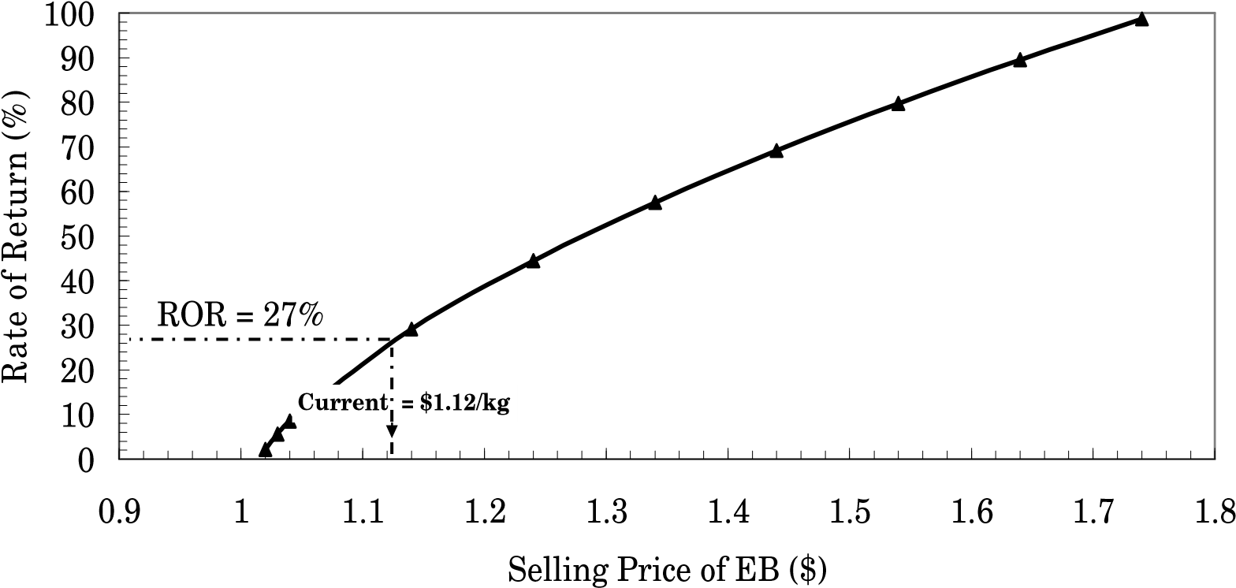

Figure 4-1: Rate of return as a function of selling price.

Figure 4-2 shows the relationship of total capital cost (TCI) in $/tonne-year and total operating cost (TOC) in $/tonne as a function of EB production. At the current production rate of 156,000 tonne/yr, the TCI and TOC are approximately $US 150/tonne-year and $US 1,030/tonne, respectively.

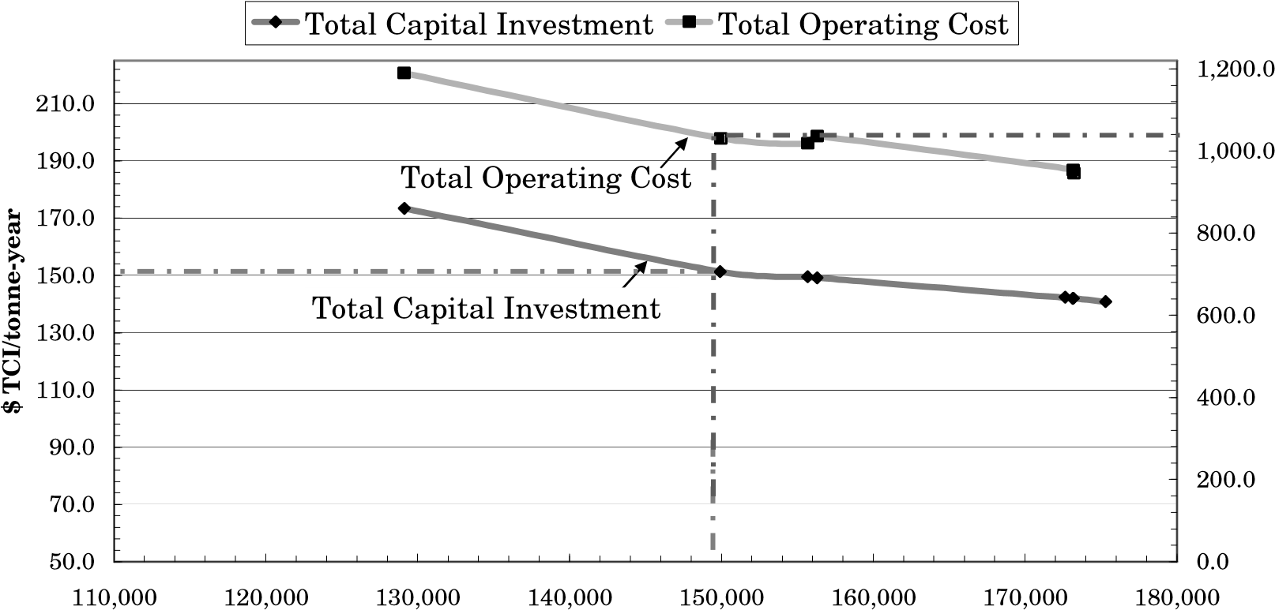

$ TOC/tonne

EB Production (tonne/yr)

Figure 4-2: Relationship of total capital cost and total operating cost as a function of EB production.

Figure 4-3 shows the relationship between ROR and ethyl benzene production for various selling prices of EB.

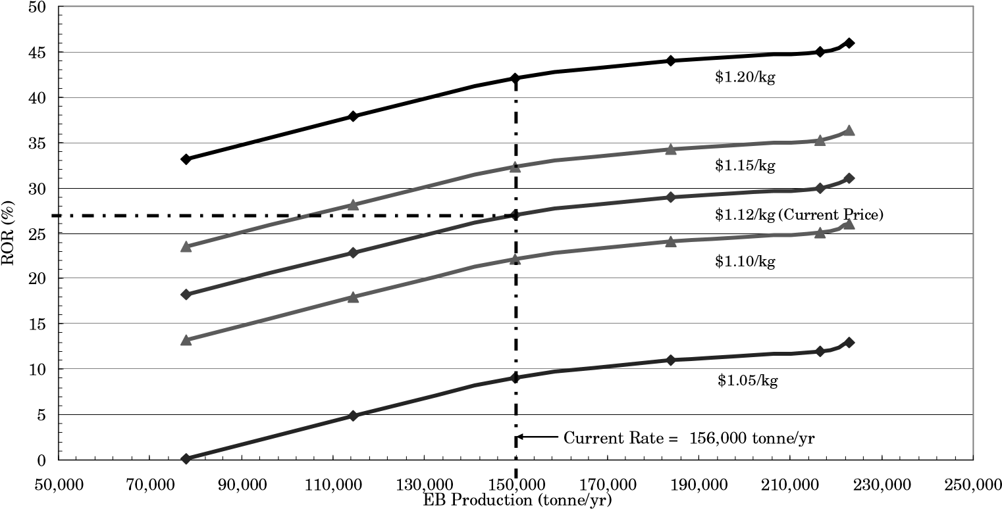

Figure 4-3: Relationship of ROR as a function of EB production for various selling prices of EB (current = $US 1.12/kg).

# Minimum Energy Requirement (From ASPEN HYSYS v9.0)

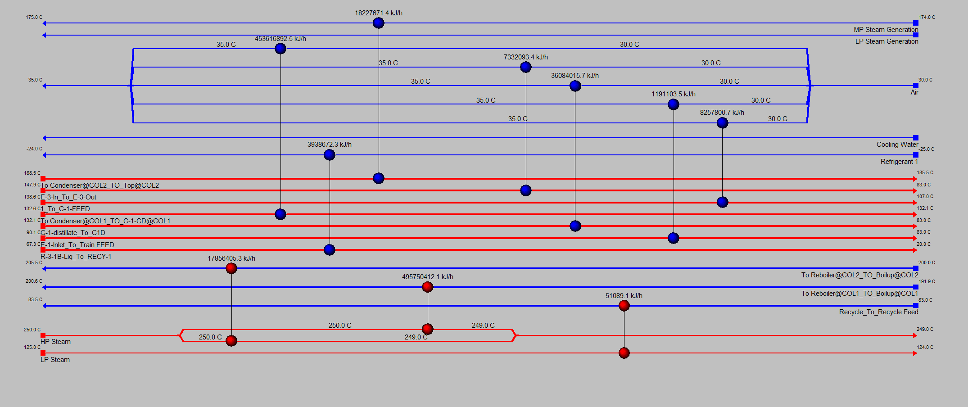

# Conclusions

Ethyl benzene is primarily a reaction intermediate in the production of styrene and styrene derived products. The Lummus/UOP EBOneTM process is one such method to synthesize EB from the reaction of benzene with ethylene. It has been successfully implemented globally at various styrene production plants. Ethyl benzene plants are generally uneconomical; however gains are made in the production of ethyl benzene derivatives, such as styrene and polystyrene. Given the small relative price difference between benzene and EB, large quantities of EB must be produced to turn a profit. The proposed production (based on Nova Chemicals’ current yearly rate), is approximately 156,000 tonne/yr. The R-1/R-2 reactor assembly contains two trains of reactors, each consisting of two alkylation reactors. Running the reactors in this fashion reduces the volumetric flow rate through each reactor, allowing for reasonably sized reactors of 35 m3. Operating temperatures and pressures range between 120°C-135°C and 1800 kPa.

The largest operational cost in the plant is the amount of raw benzene being used in the process. A recycle system has been implemented in the simulation in order to reduce the amount of purged benzene from 24,000 kg/h to 26 kg/h. In addition, this approach provides the transalkylation section with the benzene it requires for its transalkylation reaction thus eliminating the requirement of raw benzene to the R-2 reactor.

# References

1. Qi, Zhiwen and Zhang, Reishang. Alyklation of benzene with ethylene in a packed reactive distillation column, Ind. Eng. Chem. Res. v.43 (15), 4105-4111, 2004.
2. Encyclopedia of Chemical Processing Design, v.20, 77-78, 1984.
3. UOP: Petrochemical. Lummus/UOP EBOneTM Process, http://www.uop.com/objects/EBOne 20Process.pdf
4. Qi, Zhiwen and Zhang, Reishang. Alyklation of benzene with ethylene in a packed reactive distillation column, Ind. Eng. Chem. Res. v.43 (15), 4105-4111, 2004.
5. Encyclopedia of Chemical Processing Design, v.20, 77-78, 1984.
6. UOP: Petrochemical. Lummus/UOP EBOneTM Process.

http://www.uop.com/objects/EBOne%20Process.pdf

1. Tokmakov, I.V. and Lin, M.C., J. Phys. Chem. A 2004, 108, 9697-9714
2. Smith, J.M. et al., Introduction to Chemical Engineering

Thermodynamics. New York, McGraw-Hill Higher Education, 2001.

1. Sardina, H.H et al., Manufacture of Alkylbenzenes, 1991, U.S. Patent 5,003,119
2. Zhang, J et al., Process and apparatus for preparation of ethyl benzene by alkylation of benzene with dilute ethylene contained in dry gas by catalytic distillation, 2000, U.S. Patent 6,504,071
3. Standard Reaction for acidity Characterization Ethyl Benzene Disproportionation, IZA Catalysis Comission, 2002. http://www.izacatalysis.org/EB_Disprop.html.